Virtue Poker

It is a decentralized online poker network with trust, transparency, and accountability built in.

It builds on the Ethereum blockchain, the peer-to-peer networking, user-owned identity and cryptographically secured cards, these characteristics aim to improving playing experience and at a lower cost to players. The group’s aim is to fix the broken poker economy by both reducing costs to players via lower rake, building out rake back structures that encourage player retention, and through creating the most safe and secure online poker platform that will enable players to have fun on our platform, creating a more balanced online poker ecosystem.

Key points: Ethereum Blockchain, user-owned identity, cryptographically secured cards, lower rake, rake back, safe and secure online poker platform

**Technical model of the organization**

**Smart contract:**

Enable players to have full custody over their funds by using Ethereum smart contracts to escrow tournament buy-ins and autonomously distribute payouts based on game outcomes. So, players never have to deposit money onto the site and never have to request and wait for a withdrawal. It is a combination of user-owned digital wallets and Ethereum smart contracts:

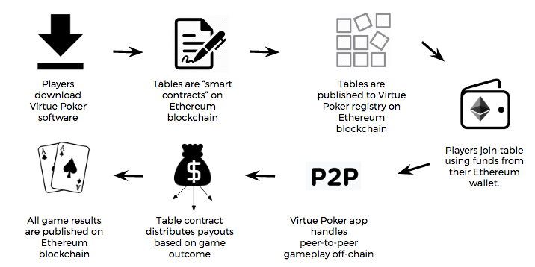

First, a player downloads Virtue Poker software and creates an account using a self-sovereign identity solution like uPort. Included in their software is a locally stored private/public key pair (wallet). Players fund their wallet by transferring ETH or VPP (our native token) to their wallet address.

A poker table on Virtue Poker uses an Ethereum smart contract which includes the custom parameters of the game (# of players, buy-in amount, game type, minimum bet size, payout, etc).

Players join a table by sending the buy-in amount to the table address and waiting for the transaction to confirm.

When a player leaves a table (cash game) or when a tournament is over (Sit and Go), the table contract auto-executes and pays out each player balance owed directly back to their wallet.

**Mental Poker Algorithm:**

Using a peer-to-peer, cryptographic shuffling protocol called Mental Poker, all players seated at a table are involved in card shuffling and reach consensus at the end of each hand using a Byzantine Fault Tolerant consensus mechanism.

The basic algorithm is as follows: Three players, Bob, Alice and Ted are seated at a table and are playing a game of Texas Hold’em. Bob is the dealer, and he generates a deck of 52 cards on his machine, only he can view the cards. Using Fisher-Yates /dev/random he shuffles the deck of cards, and then encrypts the deck with the same encryption key on each card, making the deck unreadable to anyone but himself. He then passes the now encrypted deck to Alice, who does the same thing: shuffles the deck of cards and then encrypts them. Finally, Alice passes the deck to Ted who goes through the same process.

**Justice System (proof of stack):**

The “Justice Pool” is comprised of a limited number of users that are active on the Virtue Poker network. In order to become a Justice, users must acquire VPP, stake tokens in the Justice Registry, and must have their machine on and their application open and set to “active” in order to be assigned to tables.

**Justice Submissions Review Process:**

Submissions by Justices to IPFS will be reviewed by a team of game security experts that will be consultants hired by Virtue Poker. The Virtue Poker team includes a game integrity and security expert who is assisting our developer team in building the Justice and setting up appropriate tracking software to detect red flags on the platform.

**Key points: Smart Contract, Mental poker algorithms, Justice System, JSRP**

Business model of the organization

**How they acquire players:**

They acquire players through a several pronged approaches. First, they utilize traditional marketing in both blockchain and poker spheres. Second, they believe the unique value proposition of their platform to existing players in the industry will cause significant viral adoption. Third, to promote such adoption, they have entered into several exciting relationships with some of the most recognizable names in poker. Fourth, they will host and subsidize promotional events on the platform to generate significant interest (e.g. celebrity tournaments and special games).

**What will the rake be on the Virtue Poker :**

They did not decide the final edition rake structures because they still testing the multiple rake structures through their private beta. But the main idea is they want to have the lowest rake in online poker to create a larger share of winning players and encourage players to continue playing their platform.

**rakeback, deposit bonuses, referral credits, and affiliate programs;**

They will use VPP to offer rakeback , deposit bonuses, referral credits and affiliate deals with their players and partners. They want to leverage these programs to create a more balanced and fair poker economy enable users to enjoy using their platform and encourage player retention.

**Competitive advantages:**

1. They don’t need costly servers and payment processors costs and operate at a lower cost than traditional server-based platforms.
2. It eliminates player deposit risk, as well as reduce player concerns about the integrity of games on their platform.
3. Building on the Ethereum environment will let the Ethereum developers from their community easily build new projects that integrate with Virtue Poker.

**The future of the company:**

For now, they just focus on building a successful online poker platform. In the future, they may explore integrations with other iGaming companies.

Also, they want to conduct the token launch of VPP soon.

The revenue of the Virtue Poker:

They will earn some money from the users’ rake, even though they said they are the lowest rake in online poker and they said they will put much back to the system, but it still works out for earning enough money for them.

Also, the advertisement will be the huge income source. I searched online about the Virtue.Poker page views per day, it is about 550 unique visitors and 880 page views per day which should earn about $4.39/day from advertising revenue. But I think after their platform running, the amount will be huge.

**Key points: acquire players, rack, rackback, competitive advantage, future, revenue**.

What are the platform characteristics of the organization’s technical/business strategy?  How might they take advantage of platform strategies?

Transparency: With the characteristics of the blockchain, there is no trust issues. And they can monitoring each other in some sense.

Currency transfer: they can use both ETH and VPP as the virtus

Scalability: It build on the Ethereum network which means it can integrated many other programs on it.

Gravity: they will be very attractive to poker players, the first reason is the lower rake and they reduce the risk of users lose their deposit, user can manage their virtual wallet directly.

Security: Because of the Justice System, it is not easily to break the system and also the JSRP will double check of the outcomes.

**The problems they might have:**

Connection: In my opinion, It still need times for the coming of this blockchain platform applications. Because how easily others can plug into the platform to share and transact is kind of determinant of the number of the platform’s use. In this whitepaper, they have to use ETH and VFF to fund the virtual wallet. In some sense, part of the users are not familiar to virtual currency, it is hard to get the fund. If they can have some rules like award 10 VFF when u register successful which can help them start the game easier I think is better.